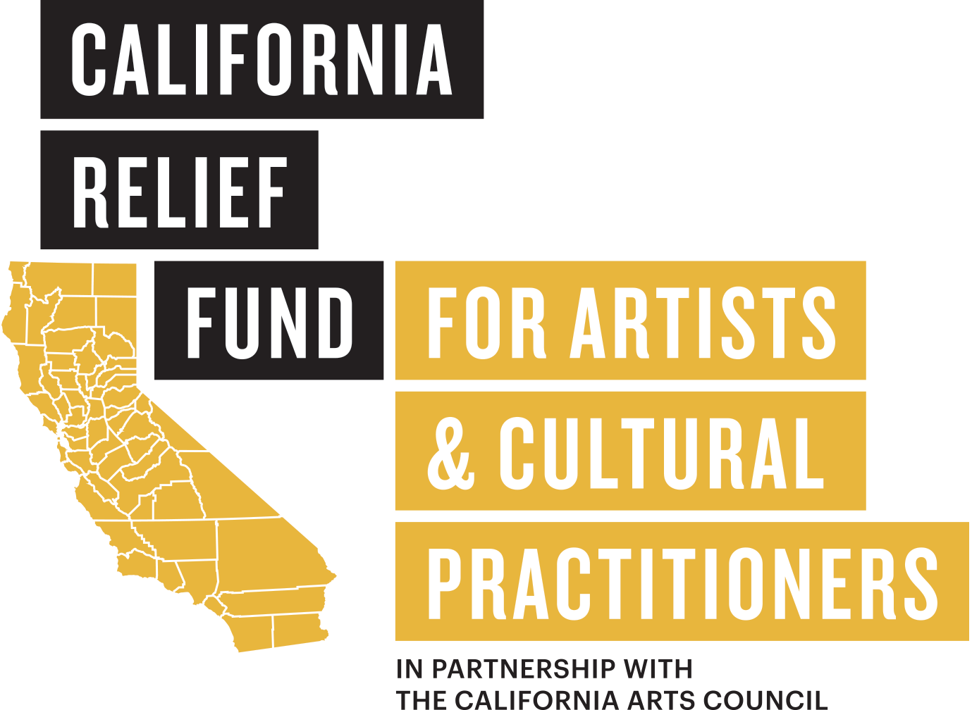

The California Relief Fund for Artists and Cultural Practitioners is a partnership between the California Arts Council (CAC) and Yerba Buena Center for the Arts (YBCA). The California Relief Fund for Artists and Cultural Practitioners is distributing approximately 1.95 million dollars from CAC’s general fund to help artists and cultural practitioners (including fine and performing artists, teaching artists, culture bearers, and other creative entrepreneurs) who reside in the rich and diverse cultural communities of the state of California. YBCA has been entrusted to administer this relief fund.
ABOUT THE FUND
The California Relief Fund for Artists and Cultural Practitioners was initiated by the California Arts Council, a state agency with a mission of strengthening arts, culture, and creative expression as the tools to cultivate a better California for all. It supports local arts infrastructure and programming statewide through grants, initiatives, and services. The California Arts Council envisions a California where all people flourish with universal access to and participation in the arts.
The Fund will be distributed to reflect the cultural and geographic diversity of the state of California—including those whose artistic practice is deeply rooted in historically marginalized communities. For the purpose of this relief fund, these prioritized communities include African, American Indian and Alaska Native, Arab, Asian and Asian American, Black and African American, Disabled, Immigrant, Indigenous and Indigena, Latinx, LGBTQIA2S+, MENASA, Native Hawaiian and Pacific Islander, Refugee, and Women. In addition, we encourage those who are low-income, have difficulty obtaining or retaining sources of income, live in rural communities, or undocumented to apply.
The California Relief Fund for Artists and Cultural Practitioners makes available $1,953,000 total, in $1,000 award amounts, to artists and cultural practitioners (i.e., fine artists, including literary, visual, and performing artists; teaching artists; culture bearers; and maker-based sole or collective-based creative social entrepreneurs) who are current, full-time residents of the state of California. For the purpose of this relief fund, an applicant must be self-employed artist, an artist entrepreneur, or employed by a nonprofit organization with arts and culture being essential to their mission.

APPLYING & REVIEW PROCESS
Applications will be accepted from noon April 25 until 5:00pm on May 20, 2022. Applicants will be notified about their award status in June 2022 and funds will be disbursed no later than July 31, 2022. If more application requests are received than funding allows, YBCA will prioritize applicants with artistic practices deeply rooted in historically marginalized communities and a lottery system will be utilized. For the purpose of this relief fund, the prioritized communities include African, American Indian and Alaska Native, Arab, Asian and Asian American, Black and African American, Disabled, Immigrant, Indigenous and Indigena, Latinx, LGBTQIA2S+, MENASA, Native Hawaiian and Pacific Islander, Refugee, and Women.
The $1,000 payments will be unrestricted and can be used toward any personal expenses that alleviate financial pressures due to the COVID-19 federally recognized qualified disaster. As long as COVID-19 is still designated as such at the time payments are disbursed, this payment is non-taxable income. Receiving support does not require that the recipient is obligated to perform any work for YBCA or the state of California. Awardees will receive an online survey about the impact and use of the funds. The survey responses will provide important information about how to best meet the needs of those working in the arts.

ELIGIBILITY REQUIREMENTS

To apply for the California Relief Fund for Artists and Cultural Practitioners, applicants:
- Must be a current, full-time resident of the state of California; and must provide proof of residency;
- Must be an artist or cultural practitioner; and must provide proof that demonstrates the applicant’s professional role in arts and culture;
- Must be at least 18 years of age at the time of applying;
- Cannot have a conflict of interests (family or financial relationships) with the boards, staff, and directors of Yerba Buena Center for the Arts, California Arts Council, or state-level elected officials and their staff; and
- Can only apply once.
APPLICATION
The simple application is divided into six (6) sections:
- Eligibility - an applicant must confirm that they are eligible to apply;
- General Information - an applicant must provide general information about themselves such as their name, contact information, county of residence, etc;
- Economic Hardship - an applicant must confirm they have experienced economic hardship due to the COVID-19 pandemic;
- Artistic Practice - an applicant must detail their artistic practice and state if their practice is deeply rooted in one of our priority communities;
- Confirmation and Submission - an applicant must confirm that all the information provided is correct and true;
- Demographics - an applicant may provide demographic information for the California Arts Council to better understand who this program served.

TURN-AROUND & PAYMENT PROCESS
If your application is selected, YBCA’s Community Investment Team will reach out to you with an email notification. That notification will be followed by an agreement and financial forms, via DocuSign. Please review, complete, and sign the DocuSign as soon as possible. Payment will not be processed or disbursed until the DocuSign is completed. Once completed, expect payment in 5-7 business days. All applicants that are not awarded will receive an email notification by the end of August 2022.
● Monday, April 25, 2022 at 12:00pm PST– Application Opens
● Friday, May 20, 2022 at 5:00pm PST– Application Closes
● June 2022 – Awardees Notifications Made
HOW TO APPLY

Applications will be accepted from Monday, April 25, 2022 at 12:00pm PST until Friday, May 20, 2022 at 5:00pm PST.

Completed applications must be submitted by the deadline—no exceptions will be made.

The California Relief Fund for Artists and Cultural Practitioners online application can be accessed at https://ybca.org/california-relief-fund/ on April 25, 2022.

Applications will be accepted in the several languages. In the top right-hand corner of the application, an applicant will be able to select the language they would like the application to be presented in. If you are having any trouble selecting, please contact YBCA (artistrelief@ybca.org) or we suggest asking a friend, neighbor, or family member to assist you. The application is brief and simple, and we encourage non-English speakers to apply.

FREQUENTLY ASKED QUESTIONS

What types of documents can I provide for my proof of California Residency?
You must submit a document from a third party that clearly shows your name and current address. We will accept the following documents as proof of residency:
- Driver’s license or government-issued ID card
- Utility bill (electricity, water, gas, internet service, or phone bill)
- Health insurance statement or medical bill
- Bank or credit card statement
- Statement of government benefits (this could include SSI, SSDI, SNAP, etc)
- A signed letter on the letterhead of the shelter you reside in
We only need to see the name and address on your document. You do not need to upload the entire document. Please cover up all sensitive information.

What types of documents can provide for my Proof of Artistic Practice?
You must provide documentation that demonstrates your working role in the arts and culture field. This can be illustrated by, but is not limited to:
- An artist’s website or social media page
- An artist CV/resume
- Visual or video work sample
- A playbill or program
- A publication copyright
- A list of public presentations/performances
- All documentation must include the artist’s name.

Which file types are acceptable for Proof of Residency and Proof of Artistic Practice?
The only file types supported for uploads are PDF, DOC, DOCX, PNG, JPG, JPEG, and GIF. For proof of artistic practice, there is a space to provide a website. If you would like to share an audio or video file for your proof of artistic practice, please provide a link to Youtube, Soundcloud, Dropbox, or another file-sharing service in the space allotted for a website.

QUESTIONS
If you have questions about the Fund or the application process, contact YBCA at artistrelief@ybca.org with the subject line: “CA Relief Fund” and your best contact number.
In addition, YBCA staff are here to provide applicants technical support, if needed. Contact artistrelief@ybca.org with the subject line “CA Relief Fund Tech Support” for assistance. We will try to respond as quickly as possible, but we may need a full business day to respond.

